UAT SIGN OFF Date: 21/04/2022
Change Ref. Management  IN00005241 | Change Description:  Capturing of detailed RCA.
CLIENT/COUNTRY >> | ALL / GHANA
In Scope items:

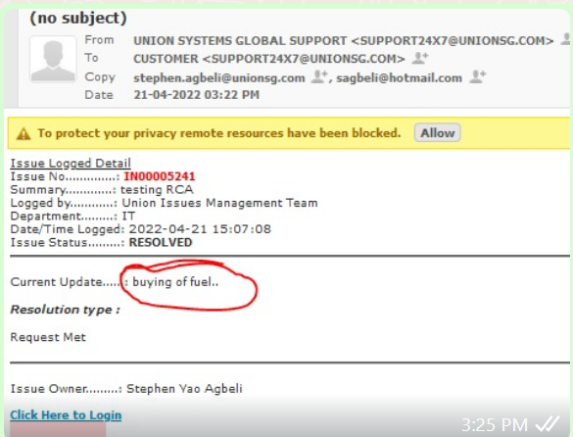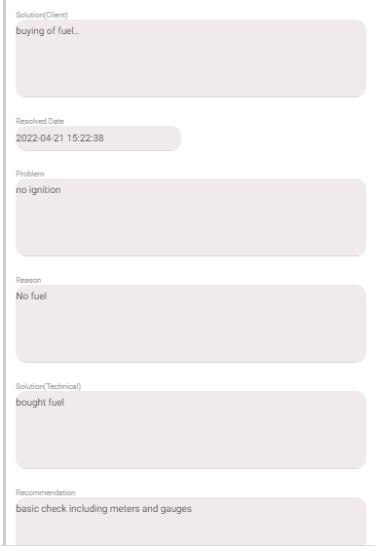

Exceptions, If Any:
>

The above test was conducted successfully. The signatories below have given their agreement to the implementation of the change as far as it impacts their area of responsibility (Unless commented otherwise).

Name | Designation | Signature | Date | Comments
Stephen Yao Agbeli | RM | ASY | 21/04/2022 | Test successfully done in the test environment
Joshua Amarfio | Developer | AJ | 22/04/2022 | Seeking approval to implement on the live environment…

